English 12
Their Eyes Were Watching God Pre-Assessment Evaluation
46 responses
Summary See complete responses
Prior to beginning the TEWWG unit, I knew _____ about the writers of the Harlem Renaissance.
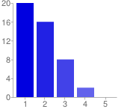  Very Little Quite a Bit | 1 - Very Little 20 43%  2 16 35%  3 8 17%  4 2 4%  5 - Quite a Bit 0 0%

Prior to beginning the TEWWG unit, I knew ____ about the background of Zora Neal Huston.
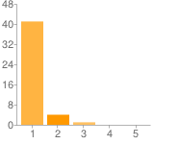  Very Little Quite a Bit | 1 - Very Little 41 89%  2 4 9%  3 1 2%  4 0 0%  5 - Quite a Bit 0 0%

Prior to beginning the TEWWG unit, I knew ____about impact of Their Eyes Were Watching God on both the African American and main street cultures.
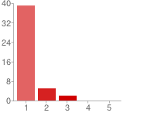  Very Little Quite a Bit | 1 - Very Little 39 85%  2 5 11%  3 2 4%  4 0 0%  5 - Quite a Bit 0 0%

Prior to beginning the TEWWG unit, I knew ____ about how the essential questions for English 12 applied to the novel.
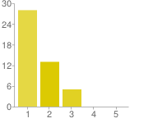  Very Little Quite a Bit | 1 - Very Little 28 61%  2 13 28%  3 5 11%  4 0 0%  5 - Quite a Bit 0 0%

Prior to beginning the TEWWG unit, I knew ___ about how the essential questions for English 12 applied to the study of the Harlem Renaissance.
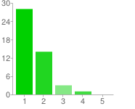  Very Little Quite a Bit | 1 - Very Little 28 61%  2 14 30%  3 3 7%  4 1 2%  5 - Quite a Bit 0 0%

Prior to beginning the TEWWG unit, I knew ___ about the symbolism of Jaine's Hair.
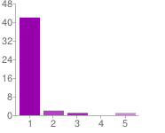  Very Little Quite a Bit | 1 - Very Little 42 91%  2 2 4%  3 1 2%  4 0 0%  5 - Quite a Bit 1 2%

Prior to beginning the TEWWG unit, I knew ___ about the symbolism of the horizon.
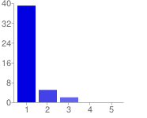  Very Little Quite a Bit | 1 - Very Little 39 85%  2 5 11%  3 2 4%  4 0 0%  5 - Quite a Bit 0 0%

Prior to beginning the TEWWG unit, I knew ___ about the symbolism of the pear tree.
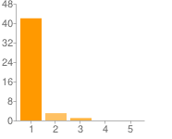  Very Little Quite a Bit | 1 - Very Little 42 91%  2 3 7%  3 1 2%  4 0 0%  5 - Quite a Bit 0 0%

Prior to beginning the TEWWG unit, I knew ___ about evolution of Janie's character.
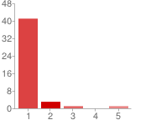  Very Little Quite a Bit | 1 - Very Little 41 89%  2 3 7%  3 1 2%  4 0 0%  5 - Quite a Bit 1 2%

Prior to beginning the TEWWG unit, I knew ___ about Eatonville.
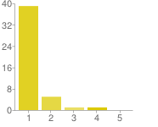  Very Little Quite a Bit | 1 - Very Little 39 85%  2 5 11%  3 1 2%  4 1 2%  5 - Quite a Bit 0 0%

Number of daily responses
