English 12
TEWWG Post Assessment Evaluation
34 responses
Summary See complete responses
After the Things Fall Apart Unit, I knew ____ about Aristotle's definition of a tragic hero.
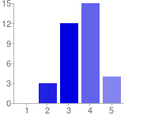  Very Little Quite a Bit | 1 - Very Little 0 0%  2 3 9%  3 12 35%  4 15 44%  5 - Quite a Bit 4 12%

After the Things Fall Apart unit, I knew ___ about the definition of hamartia.
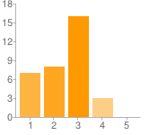  Very Little Quite a Bit | 1 - Very Little 7 21%  2 8 24%  3 16 47%  4 3 9%  5 - Quite a Bit 0 0%

After the Things Fall Apart unit, I knew ___ about peripetia.
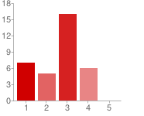  Very Little Quite a Bit | 1 - Very Little 7 21%  2 5 15%  3 16 47%  4 6 18%  5 - Quite a Bit 0 0%

After the Things Fall Apart unit, I knew ___ about porquoi stories.
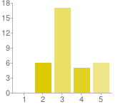  Very Little Quite a Bit | 1 - Very Little 0 0%  2 6 18%  3 17 50%  4 5 15%  5 - Quite a Bit 6 18%

After the Things Fall Apart unit, I knew ___ about whether or not Okonkwo fits Aristotle's definition of a tragic hero.
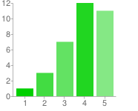  Very Little Quite a Bit | 1 - Very Little 1 3%  2 3 9%  3 7 21%  4 12 35%  5 - Quite a Bit 11 32%

After the Things Fall apart unit, I knew ____ about Okonkwo's tragic flaw.
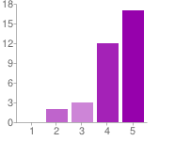  Very Little Quite a Bit | 1 - Very Little 0 0%  2 2 6%  3 3 9%  4 12 35%  5 - Quite a Bit 17 50%

After the start of the Things Fall Apart unit, I knew ____ about the Ibo people and their traditions.
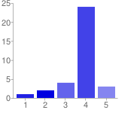  Very little Quite a Bit | 1 - Very little 1 3%  2 2 6%  3 4 12%  4 24 71%  5 - Quite a Bit 3 9%

After the Things Fall Apart unit, I knew ____ about how the essential questions (about leadership) for English 12 relate to the novel.
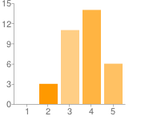  Very Little Quite a Bit | 1 - Very Little 0 0%  2 3 9%  3 11 32%  4 14 41%  5 - Quite a Bit 6 18%

After the start of the Things Fall Apart unit, I knew ___ about why this novel is studied in high schools across the U.S.A.
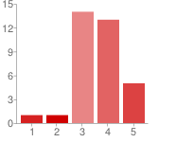  Very Little Quite a Bit | 1 - Very Little 1 3%  2 1 3%  3 14 41%  4 13 38%  5 - Quite a Bit 5 15%

Number of daily responses
