English 10
Adventures of Huckleberry Finn Pre-Assessment
Summary See complete responses
Prior to beginning the Huck Finn unit, I had a clear understanding of satire.
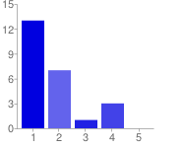  Very Little Quite a Bit | 1 - Very Little 13 54%  2 7 29%  3 1 4%  4 3 13%  5 - Quite a Bit 0 0%

Prior to beginning the Huck Finn unit, I had a clear understanding of Mark Twain's motivations for writing the novel.
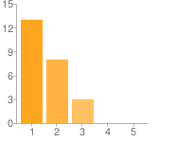  Very Little Quite a Bit | 1 - Very Little 13 54%  2 8 33%  3 3 13%  4 0 0%  5 - Quite a Bit 0 0%

Prior to beginning the Huck Finn unit, I had a clear understanding of the historical context of the novel.
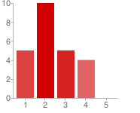  Very Little Quite a Bit | 1 - Very Little 5 21%  2 10 42%  3 5 21%  4 4 17%  5 - Quite a Bit 0 0%

Prior to beginning the Huck Finn unit, I had a clear understanding of the the statements about society that Mark Twain attempted to make in his novel.
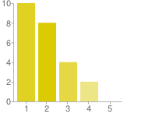  Very Little Quite a Bit | 1 - Very Little 10 42%  2 8 33%  3 4 17%  4 2 8%  5 - Quite a Bit 0 0%

Prior to beginning the Huck Finn unit, I had a clear understanding of the controversy involving the novel.
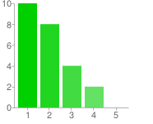  Very Little Quite a Bit | 1 - Very Little 10 42%  2 8 33%  3 4 17%  4 2 8%  5 - Quite a Bit 0 0%

Prior to beginning the Huck Finn unit, I had a clear understanding of the relevance of the novel in today's society.
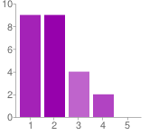  Very Little Quite a Bit | 1 - Very Little 9 38%  2 9 38%  3 4 17%  4 2 8%  5 - Quite a Bit 0 0%

Prior to beginning the Huck Finn unit, I had a clear understanding of the elements of an argumentative speech.
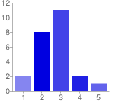  Very Little Quite a Bit | 1 - Very Little 2 8%  2 8 33%  3 11 46%  4 2 8%  5 - Quite a Bit 1 4%

Number of daily responses
