English 10
The Adventures of Huckleberry Finn Post-Assessment
17 responses
Summary See complete responses
After the OMAM unit, I was knowledgeable about the life of the Migrant Worker in the Great Depression.
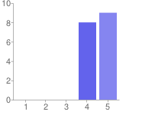  Very Little Quite a Bit | 1 - Very Little 0 0%  2 0 0%  3 0 0%  4 8 47%  5 - Quite a Bit 9 53%

After the OMAM unit, I understood elements of John Steinbeck's writing style which include strong, natural imagery and regional dialect.
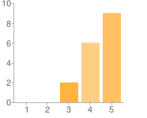  Very Little Quite a Bit | 1 - Very Little 0 0%  2 0 0%  3 2 12%  4 6 35%  5 - Quite a Bit 9 53%

After the OMAM unit, I understood how the novel mimics a play.
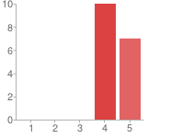  Very Little Quite a Bit | 1 - Very Little 0 0%  2 0 0%  3 0 0%  4 10 59%  5 - Quite a Bit 7 41%

After the OMAM unit, I understood how to identify hyperbole, allusion, and symbolism in poetry.
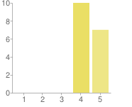  Very Little Quite a Bit | 1 - Very Little 0 0%  2 0 0%  3 0 0%  4 10 59%  5 - Quite a Bit 7 41%

After the OMAM unit, I understood why certain camera angles, cross cutting, and P.O.V. shots were utilized by directors in film.
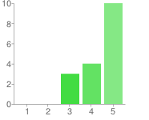  Very Little Quite a Bit | 1 - Very Little 0 0%  2 0 0%  3 3 18%  4 4 24%  5 - Quite a Bit 10 59%

AFter the OMAM unit, I understood the relevance of the novel in current society.
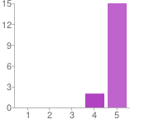  Very Little Quite a Bit | 1 - Very Little 0 0%  2 0 0%  3 0 0%  4 2 12%  5 - Quite a Bit 15 88%

After the OMAM unit, I understood the how the theme of the American Dream relates to the novel.
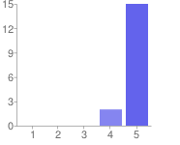  Very Little Quite a Bit | 1 - Very Little 0 0%  2 0 0%  3 0 0%  4 2 12%  5 - Quite a Bit 15 88%

Number of daily responses
