English 10
The Crucible Pre-Assessment
31 responses
Summary See complete responses
Prior to beginning The Crucible Unit, I knew ___ about McCarthyism.
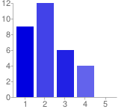  Very Little Quite a Bit | 1 - Very Little 9 29%  2 12 39%  3 6 19%  4 4 13%  5 - Quite a Bit 0 0%

Prior to beginning the Crucible Unit, I knew___ about the Red Scare.
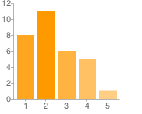  Very Little Quite a Bit | 1 - Very Little 8 26%  2 11 35%  3 6 19%  4 5 16%  5 - Quite a Bit 1 3%

Prior to beginning The Crucible Unit, I knew ___ about Arthur Miller.
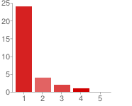  Very Little Quite a Bit | 1 - Very Little 24 77%  2 4 13%  3 2 6%  4 1 3%  5 - Quite a Bit 0 0%

Prior to beginning The Crucible Unit, I knew ___ about Puritanism.
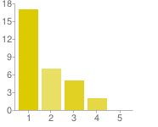  Very Little Quite a Bit | 1 - Very Little 17 55%  2 7 23%  3 5 16%  4 2 6%  5 - Quite a Bit 0 0%

Prior to beginning The Crucible Unit, I knew ___ about the Salem Witch Trials.
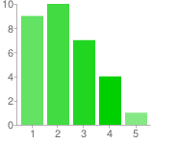  Very Little Quite a Bit | 1 - Very Little 9 29%  2 10 32%  3 7 23%  4 4 13%  5 - Quite a Bit 1 3%

Prior to beginning The Crucible Unit, I knew ____ about persuasive writing.
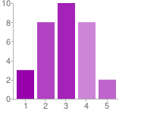  Very Little Quite a Bit | 1 - Very Little 3 10%  2 8 26%  3 10 32%  4 8 26%  5 - Quite a Bit 2 6%

Prior to beginning The Crucible Unit, I knew ___ about integrating quotations in my MLA essay.
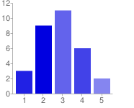  Very Little Quite a Bit | 1 - Very Little 3 10%  2 9 29%  3 11 35%  4 6 19%  5 - Quite a Bit 2 6%

Prior to beginning The Crucible Unit, I knew ___ about citing on-line sources in a Works Cited page.
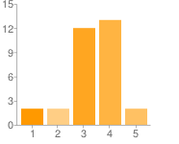  Very Little Quite a Bit | 1 - Very Little 2 6%  2 2 6%  3 12 39%  4 13 42%  5 - Quite a Bit 2 6%

Prior to beginning the Crucible Unit, I knew ___ about MLA parenthetical documentation.
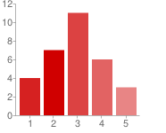  Very Little Quite a Bit | 1 - Very Little 4 13%  2 7 23%  3 11 35%  4 6 19%  5 - Quite a Bit 3 10%

Number of daily responses
