English 10
The Crucible Post-Assessment
26 responses
Summary See complete responses
After The Crucible Unit, I know ___ about McCarthyism.
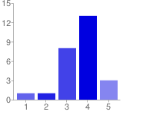  Very Little Quite a Bit | 1 - Very Little 1 4%  2 1 4%  3 8 31%  4 13 50%  5 - Quite a Bit 3 12%

After The Crucible Unit, I know ___ about the Red Scare.
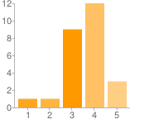  Very Little Quite a Bit. | 1 - Very Little 1 4%  2 1 4%  3 9 35%  4 12 46%  5 - Quite a Bit. 3 12%

After The Crucible Unit, I know ___ about Arthur Miller.
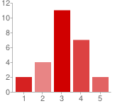  Very Little Quite a Bit | 1 - Very Little 2 8%  2 4 15%  3 11 42%  4 7 27%  5 - Quite a Bit 2 8%

After The Crucible Unit, I know ____ about Puritanism.
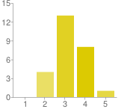  Very Little Quite a Bit | 1 - Very Little 0 0%  2 4 15%  3 13 50%  4 8 31%  5 - Quite a Bit 1 4%

After The Crucible Unit, I know ____ about how to properly integrate quotations in MLA format.
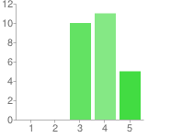  Very Little Quite a Bit | 1 - Very Little 0 0%  2 0 0%  3 10 38%  4 11 42%  5 - Quite a Bit 5 19%

After The Crucible Unit, I know ____ about persuasive essay writing.
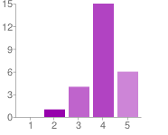  Very Little Quite a Bit | 1 - Very Little 0 0%  2 1 4%  3 4 15%  4 15 58%  5 - Quite a Bit 6 23%

After The Crucible Unit, I know ____about parenthetical documentation in MLA format.
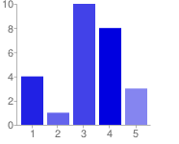  Very Little Quite a Bit | 1 - Very Little 4 15%  2 1 4%  3 10 38%  4 8 31%  5 - Quite a Bit 3 12%

After The Crucible Unit, I know ____ about citing on-line sources in an MLA formatted Works Cited page.
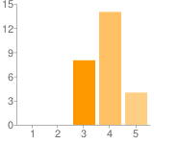  Very Little Quite a Bit | 1 - Very Little 0 0%  2 0 0%  3 8 31%  4 14 54%  5 - Quite a Bit 4 15%

After The Crucible Unit, I know _____ about the connection between McCarthyism and the Salem Witch Trials.
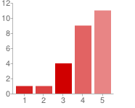  Very Little Quite a Bit | 1 - Very Little 1 4%  2 1 4%  3 4 15%  4 9 35%  5 - Quite a Bit 11 42%

After The Crucible Unit, I know ____ about the significance of The Crucible in today's culture. (i.e. Why the play is studied in school...)
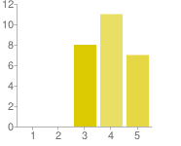  Very Little Quite a Bit | 1 - Very Little 0 0%  2 0 0%  3 8 31%  4 11 42%  5 - Quite a Bit 7 27%

Number of daily responses
